Problem: PH company is a bicycles manufacturer, and it produces two types of products: street and road bicycles. The final products are put together via two assembling processes: 1 and 2. There are 3 time periods. Below is process costs for process 1 and process 2 and resource requirement per unit:

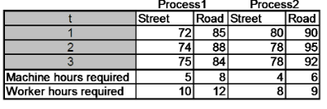

To meet customer demands in time in the US, planning department conducted a demand forecasting and counted current initial inventory.

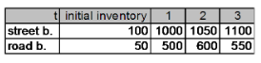

Besides, the information about available capacity(hours) and holding costs per bike are below:

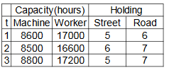

Help planning department to determine the aggregate production plan that minimizes the cost of meeting customer’s demands.

Model:

Parameters:

$T_{t}$: *horizon length, in periods, $t∈(1,2,3)$*

$N_{i}$: *Number of products, $i∈(1,2)$*

$K_{k}$: *Number of resource types, $k∈(1,2)$*

$D_{it}$: *forecasted number of units demanded for product i in period t*

$m_{i}$: *number of different processes available to make product i*

$A_{kt}$: *amount of resource k available in period t*

$a_{ijk}$: *amount of resources k required by one unit of product i if produced by process j*

$C_{ijt}$: *cost to produce one unit of product i using process j in period t*

$C_{it}$: *cost to hold one unit of product i in inventory for period*

Decisions:

$P_{ijt }$: *Number of units of product i produced by process j in period t*

$I_{it }$: *Number of units of product i held in inventory at the end of period t*

Objective: *Minimize total cost*

$$min\sum_{t=1}^{T}{\sum_{i=1}^{N}{\sum_{j=1}^{m_{i}}{{(C}_{ijt}^{P}*P_{ijt }+ C_{it}^{I}I_{it }})}}$$

Constraints:

$P_{ijt }, I_{it }≥0 and int, i∈\{1,2\} ,t∈(1,2,3), k∈(1,2) \left(1\right)$ decision var are non-negative and integer

$\sum_{i=1}^{N}{\sum_{j=1}^{m_{i}}{a_{ijk}P_{ijt}} ≤ A_{kt}} \left(2\right)$ Production must not be exceeding the available resources

$I_{it}=I_{it-1}+ \sum_{j=1}^{m_{i}}{P_{ijt} - D_{it}} \left(3\right)$ Current Inventory should be previous inventory plus current production qty minus current demand qty

Optimal Solution.

The following is the solution obtained from Excel Solver. The total cost is $368,762.

